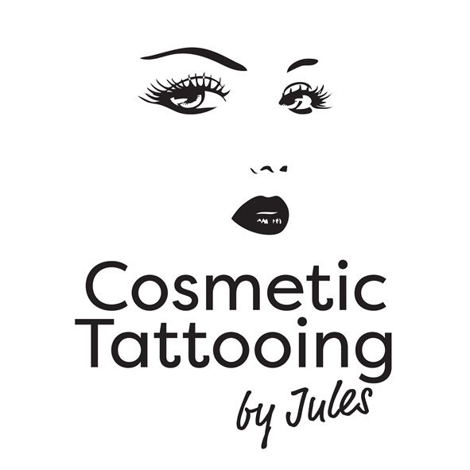

INDEMNITY CONTRACT

Practicioner: 7 Lakemba Mews
Jules Farmer Palmerston North
027 2430051
Between: Cosmetic Tattooing by Jules and Jules Farmer
(‘the practicoiner’)

And Name (‘the client’) Date_____________

Tattooing, tattoo lightening, or tattoo modification is an invasive procedure.
To avoid unforeseen complications, please indicate with a tick any of the following conditions pertaining to you.

Eye History
 Eye Makeup Allergy  Corneal Abrasions  Contact Lenses  Dry Eyes Eye or Eyelid Infection
 Glasses  Glaucoma  Light Sensitive  Ocular Herpes  Skin Tags or Milia on Eyelids
 Recent Surgery on Eyelids  Recent Lasik Surgery

Lip History
 Fever Blisters  Cold Sores  Dry, flaky or white areas on lips
 Does it take more to get you to numb than most people
 Have you had collagen, gortex, fat, alloderm fillers or silicone placed into your lips?

Skin History
 Makeup Allergies  Excessive Oily Skin  Bruise or Swell Easily  Heal Normally  Slow Healer
 Scars in treatment area  Keloid Scars  Recent laser resurfacing  Psoriasis
 Currently using Retin A or Alpha Hydroxy Acid skin care products

Medication History
 Aspirin  Other Blood Thinners  Currently or recently had Chemotherapy or Radiotherapy
 Steroids (affects the way the skin heals)

Health History
Alopecia  Diabetes  Epilepsy  Hepatitis  HIV
 Haemophilia  Dizziness  High Blood Pressure  Heart Conditions  Palpitations
 Liver Disease  Pregnant or Nursing  Lupus (slow healing)  Trichotillomania
Tendency to bleed excessively from minor injuries  Tendency to scar from minor skin injuries

 Other medical conditions (please state below)

Please initial and sign here

- I accept that it cannot be expected that the colours will remain the same intensity and darkness as they were when first created, because approximately 20 percent or more of the colour will fade from the epidermal layer of the skin during the healing process. The price paid on my 1st appointment is different to what I pay on my 2nd appointment, which has to be taken within 8 weeks after the first appointment. Otherwise there will be an extra charge to pay if it has been more than 8 weeks after 1st appointment. Maintenance touch-ups may be necessary with-in the first 18 months to keep the pigment colour looking fresh. Fees for this are based on an hourly rate. After 18 months full fee may apply depending on the amount of pigment required.

- I understand that with time the implanted pigment will gradually fade. The length of time it takes to fade depends on my skin type (oily), age, metabolism, medications, smoking, alcohol, sun exposure, Retin A and Glycolic Acids, and any problems experienced with the implantation and absorbency of the pigment into my skin.

- I understand the pigment colour implanted, plus my skin undertone colour will determine the final pigment colour. The influence of my skin undertone and the fade out rate of certain pigment colours may result in a different colour appearing. I have been consulted about the above and realize it may be necessary to have a counteracting colour added to the chosen colour mix.

- I understand that the treatment is very intense and accept there may be some initial swelling and possible bruising on formation of eyeliner and lip liner, and that there may be crust formation during healing of some procedures.

- I understand if I do not have the second treatment, I cannot expect the colour to last. The second visit is to check that the pigment healed evenly in the skin and that no more pigment needs to be added to the shape. THE FOLLOW-UP APPOINTMENT IS A VERY IMPORTANT STEP IN THE WHOLE COSMETIC TATTOOING PROCEDURE. If this 2 month follow up appointment is not kept there is no owneness on the practitioner and full price may apply depending on length of next appointment.

- I understand that if someone else does the initial pigment implantation treatment and I chose to have a re-touch, correction or removal by the Practitioner, that there will be absolutely no claim against the Practitioner arising from such remedial treatment.

- I acknowledge that no guarantees have been made to me concerning the result of this procedure. I have been given the opportunity to ask questions and they were answered to my satisfaction.

- I understand that I may break out in cold sores from any of the lip procedures and I have been advised of the necessary healing steps for possible prevention.

- I understand that I may not donate blood for a period of 12 months after having a cosmetic tattoo.

Client Signature Date

Guardians Signature (if applicable)

The Practitioner

