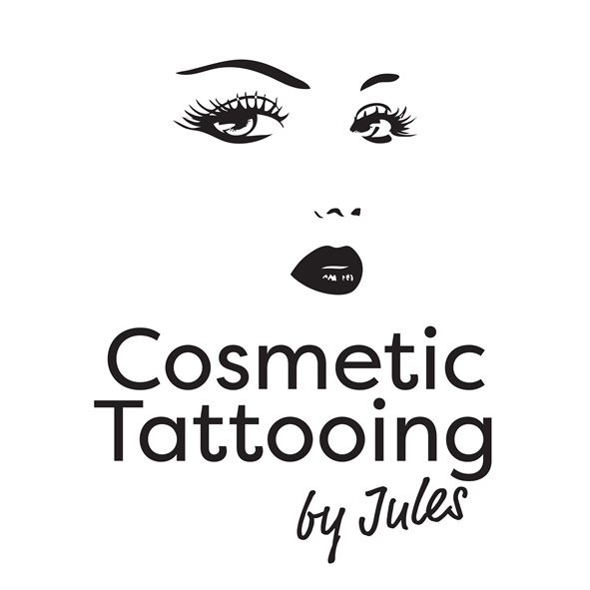
Practicioner: 7 Lakemba Mews
Jules Farmer CONTRACT FOR SERVICES Palmerston North
027 2430051
Between: COSMETIC TATTOOING by Jules and Jules Farmer
(‘the practicoiner’)
And Name (‘the client’)
Address City
Home Phone Work Phone Cell Phone
DOB Referred By Clinic Name
Email Occupation
No Alcohol or Caffeine to be consumed after 4pm day prior to your appointment.
Treatment/s Required
Please indicate which treatment you require
 Eyebrows-Powdered/Micro blade  Upper Eyeliner  Lower Eyeliner  Upper & Lower Eyeliner
 Lip Liner/Blend  Full Lip Colour  Beauty Spot  Scar Camouflage
 3D Areola Re Pigmented  Cleft Lip  Tattoo Removal  Collagen Induction

Please indicate with a tick in the box, the questions that apply to you:
 Are you under the age of 18?
 Have you had any aspirin or blood thinning products in the last 7 days?
 Are you sensitive to Latex rubber?
 Have you had Micro Pigmentation or Tattoo Treatments before?
 Did you experience any problems with the Micro Pigmentation or Tattoo procedures?
 Do you wear a pacemaker?
 Are you allergic to any metal, e.g. Nickel?
 Are you allergic to topical desensitizers of the ‘Caine’ family of drugs?
 Is there remarkable skin sensitivity?
 Do you have prosthesis or implant in the vicinity of the area to be tattooed?

If you answered YES to any of the above questions please state below a further explanation:

Your Practitioner makes no attempt to, or claim to, practice medicine. Some individuals will have complications related to permanent make-up application. These complications are usually mild and last only a few days. However, extreme complications are always a possibility. If you are healthy and there are no visible reasons restricting you from receiving a tattoo, you must approve of the design and colour before the application of your permanent make-up.

I accept MY choice of colours for the Cosmetic Tattooing procedures are:
______
____________________________________________________________________________________________________________________________________________________________________________________________________________________________________________________________________________________________________________________________________________________________________________________________________________
_________________________________________________________________________________________________

I accept the fee for the Cosmetic Tattooing procedure is to be paid for up front prior to both treatments; the 2nd appointment will be within 8 weeks after the 1st visit. I accept that there will be an additional charge for any subsequent appointments that may be necessary to obtain the desired colour or shape. For some skin types, cosmetic tattooing may be a multi-step process.

I accept that if I have already had Cosmetic Tattooing treatments before, and this appointment is for one Touch-up treatment only, there will be a one off payment unless otherwise advised by Jules Farmer.

I have read and understand the contents of each paragraph above. I acknowledge this is a contract and that I have received no warranties or guarantees with respect to the benefits to be realised from or consequences of, the aforementioned procedure(s). I further acknowledge that at the time of signing this consent, I was of sound mind and capable of making independent decisions for myself.

Client Signature Date

Guardians Signature (if applicable)

The Practitioner

PHOTOGRAPHIC RECORD
The taking of before and after photographs is standard practice for the treatment of Cosmetic Tattooing procedures - These images are of the FACIAL FEATURE BEING TREATED ONLY and stay with the Client’s treatment record file.

Many people are extremely nervous at the thought of having a coloured pigment implanted into their facial features. They find that viewing photographs is reassuring. If you would be prepared to allow your photographs to be viewed by other prospective clients, please indicate below.

I give permission for before and after photos of my Cosmetic Tattooing procedure to be used for the purpose of showing prospective clients. The facial feature treated is all that may be shown.

Client Signature Date
I give permission for my photographs to be used for the purpose of Cosmetic Tattooing by Jules.
I appreciate that others need encouragement to gain the confidence needed in realizing the benefits of the Cosmetic Tattooing procedures. There are many also who are physically or visually impaired and are not aware that they can have their facial features cosmetically tattooed. The convenience of permanent facial features would be a wonderful asset to many. Your assistance with the education of the public would be appreciated.

Client Signature Date

Thank you for your kind permission to show others how natural cosmetic and medical procedures can look.

